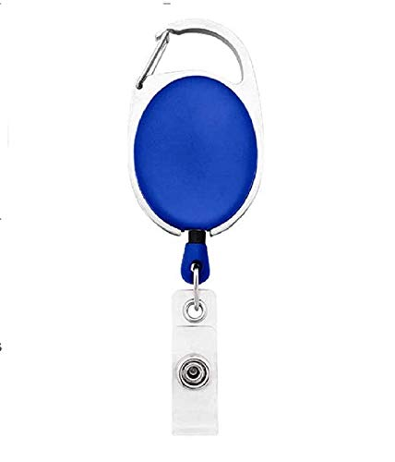

EMPLOYEE CARD

***EMP3456***

|  |  |
| --- | --- |
| **THOMAS FORTE** | PHOTO |
| **Tech Support** |
| **Joining:04/20/2022** |
| **Blood Group:O-VE** |
| **Phone:8897589834** |

www.companywebsite.com